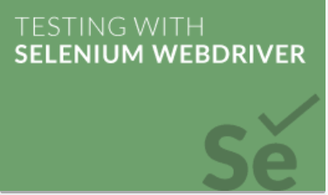

Final Project

BY: Aly Dawood

Video to Auto testing Edureka Site:

http://www.alydawood.me/vid/ed.html

Video to Auto testing Hyundai Canada Site:

http://www.alydawood.me/vid/hy.html

1.0 **Edureka web page test**

In this test case. Selenium will load eureka page and do the following:

* Load Edureka web page
* Browse through all **course categories**
* Perform text searches for python and NoSQL courses
* Click on Apache Slor Course
* View Apache Slor Curriculum
* Browse through all self-paced courses
* View Apache Strom Course
* Fill out query form
* Clear Fields of query form
* Take snap shot of each cases

**Edureka testing *configuration table*.**

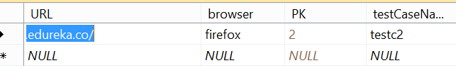

**Edureka test cases *table*.**

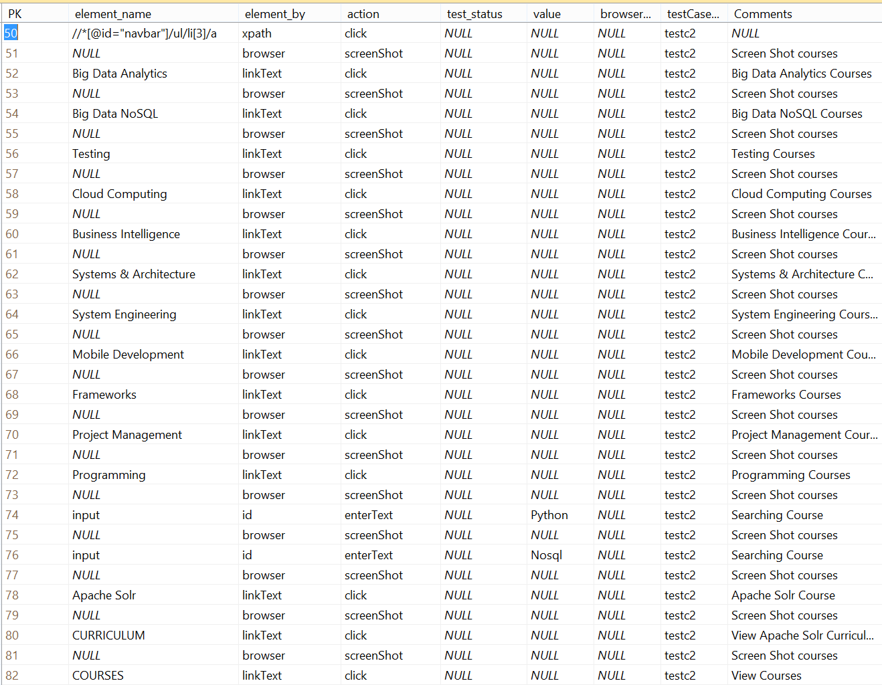

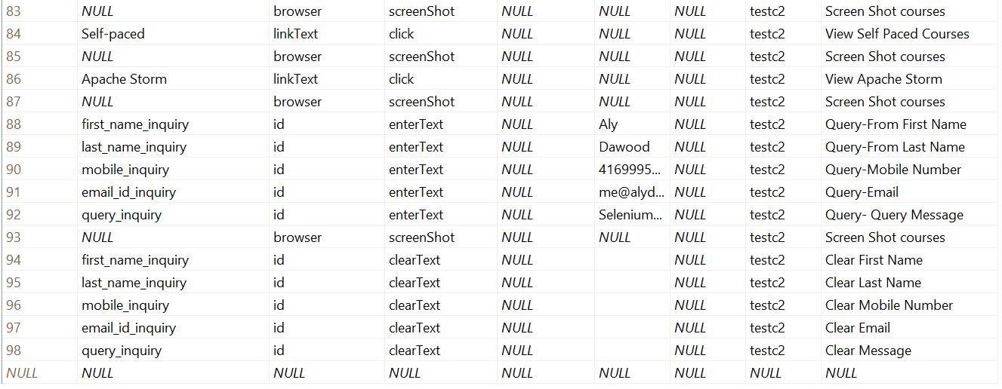

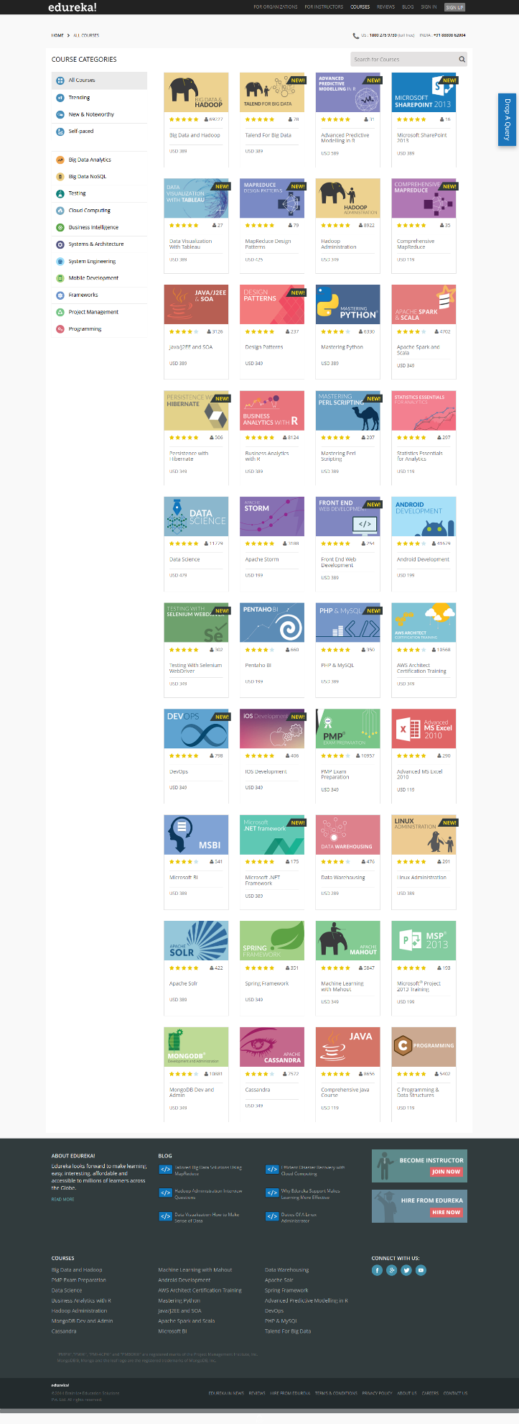

Edureka Web Site

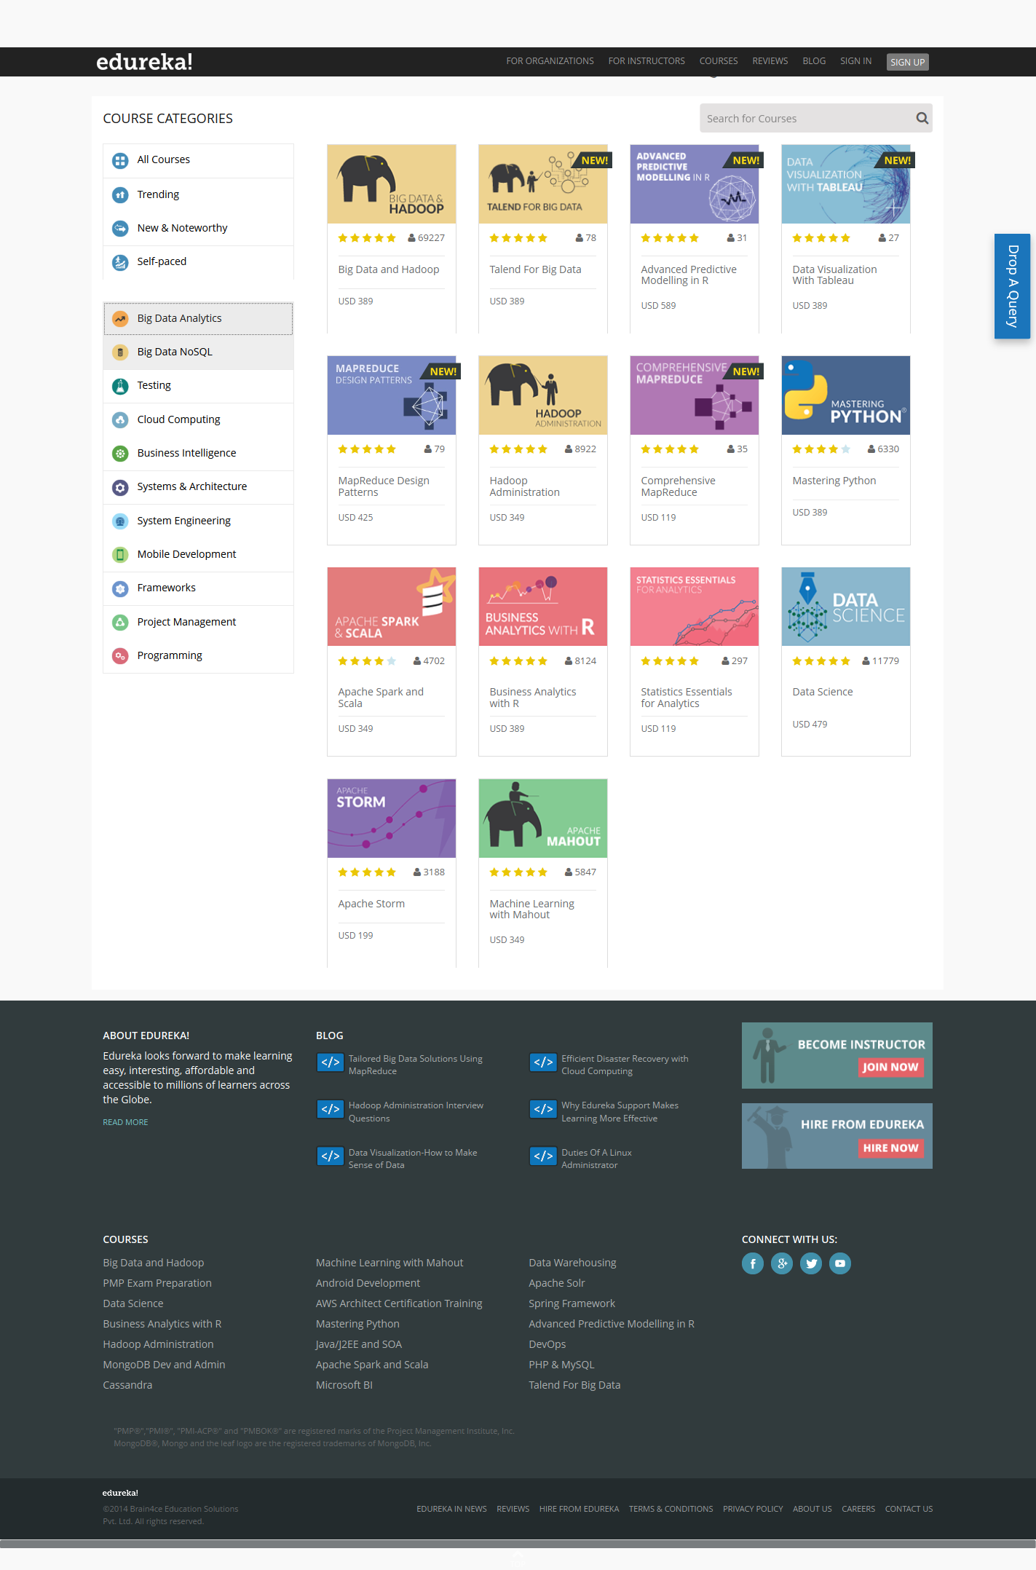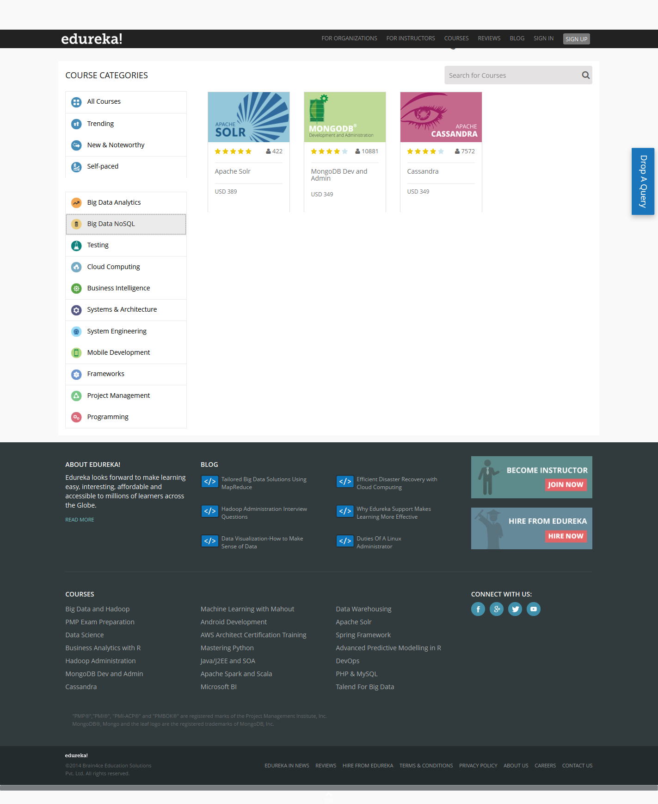

Displaying Big Data Courses

Displaying Big Data NoSQL Courses

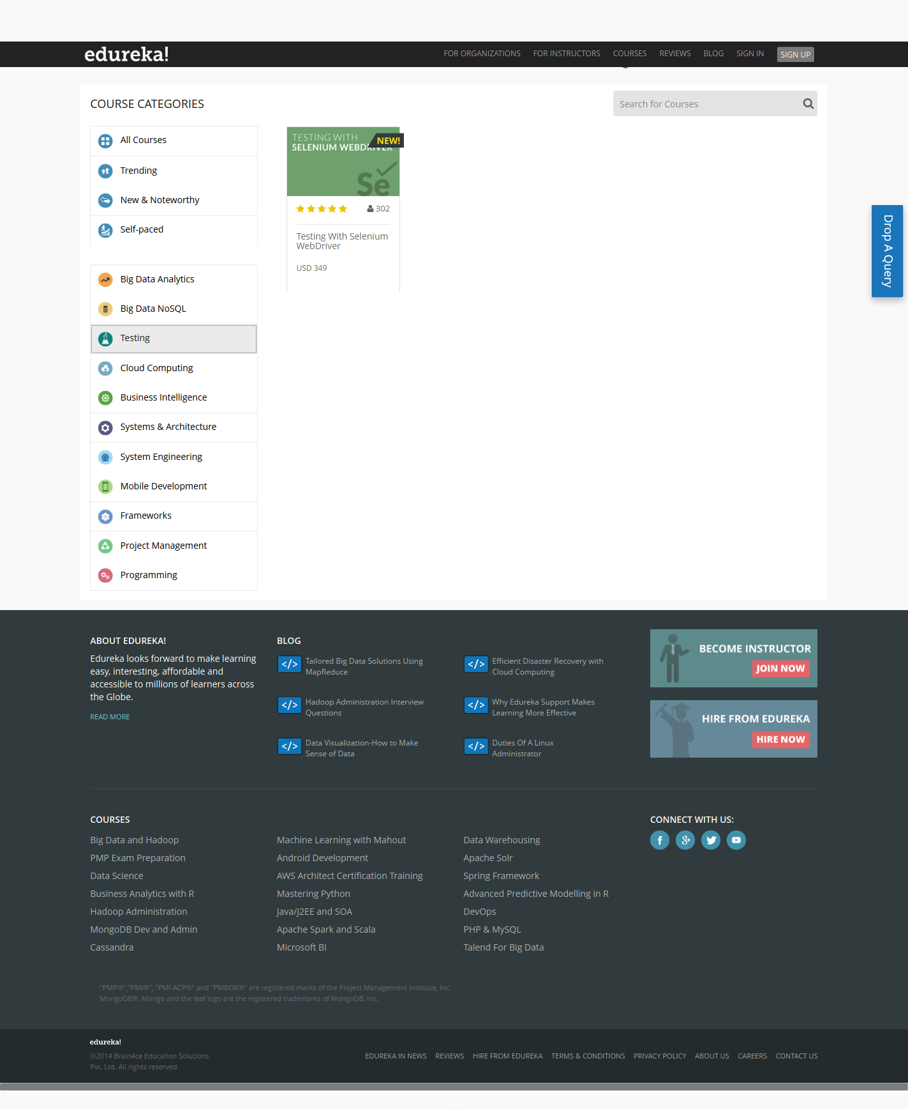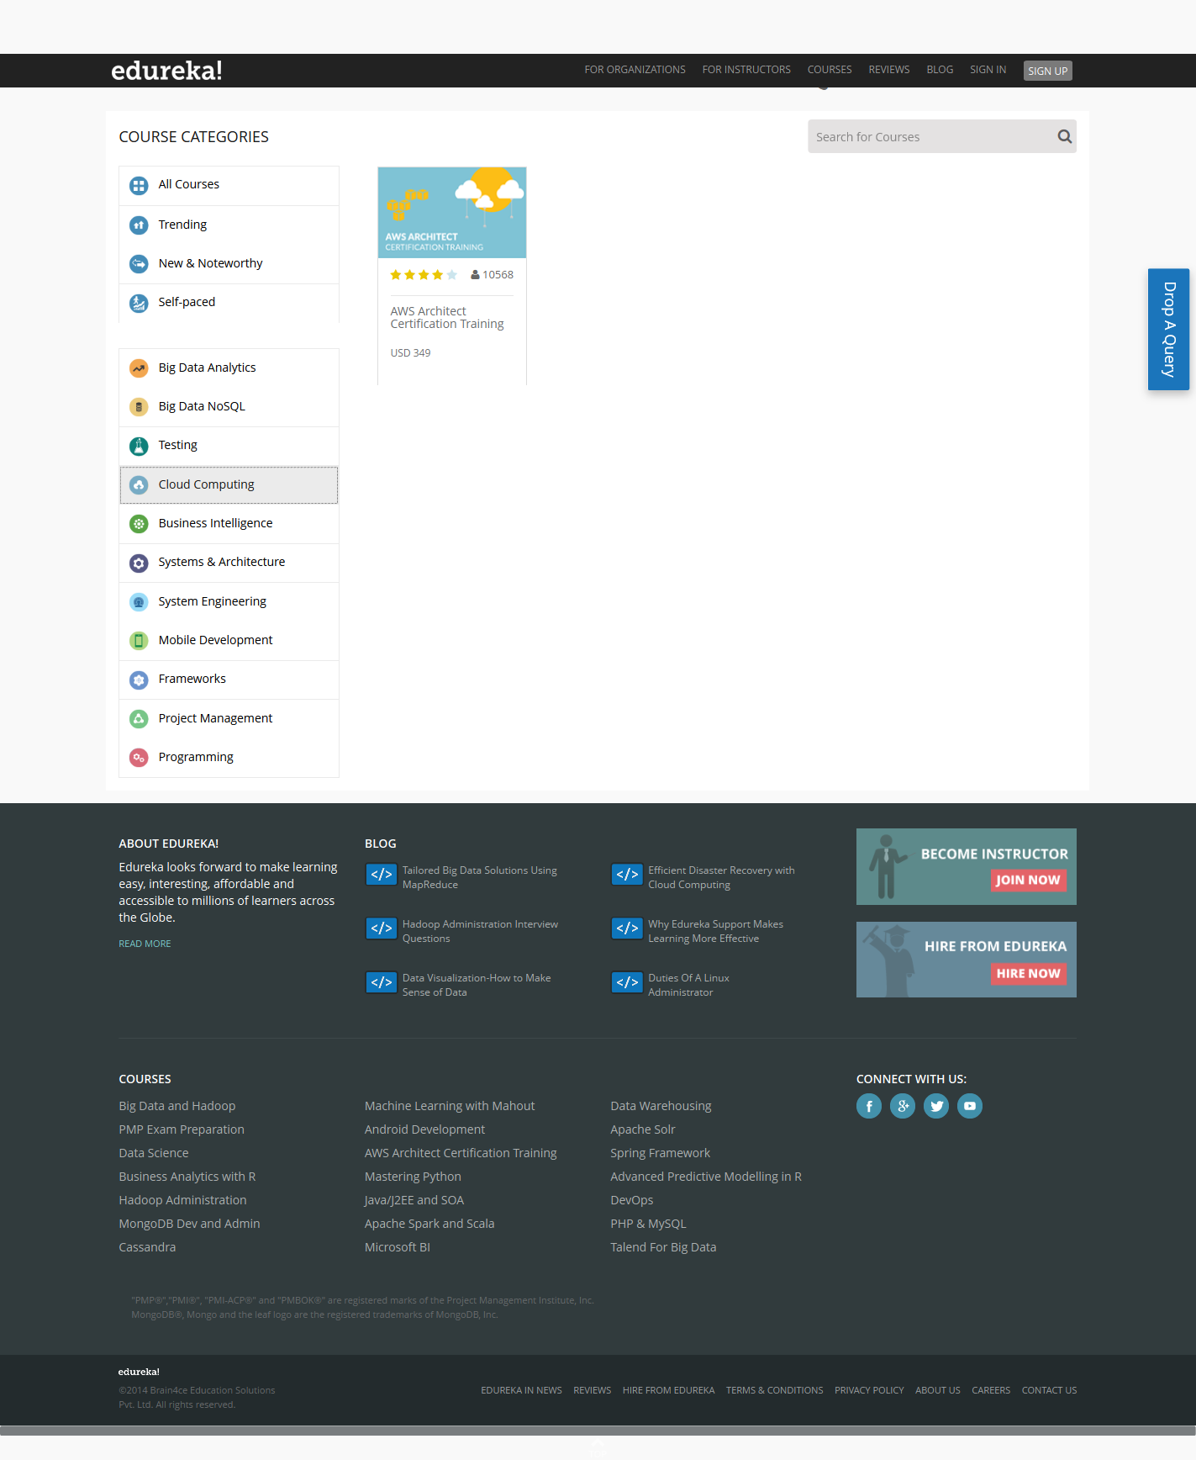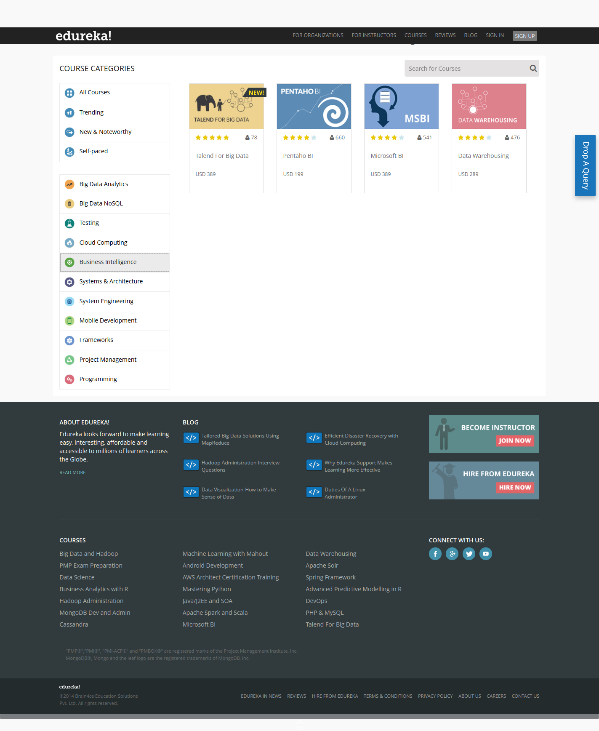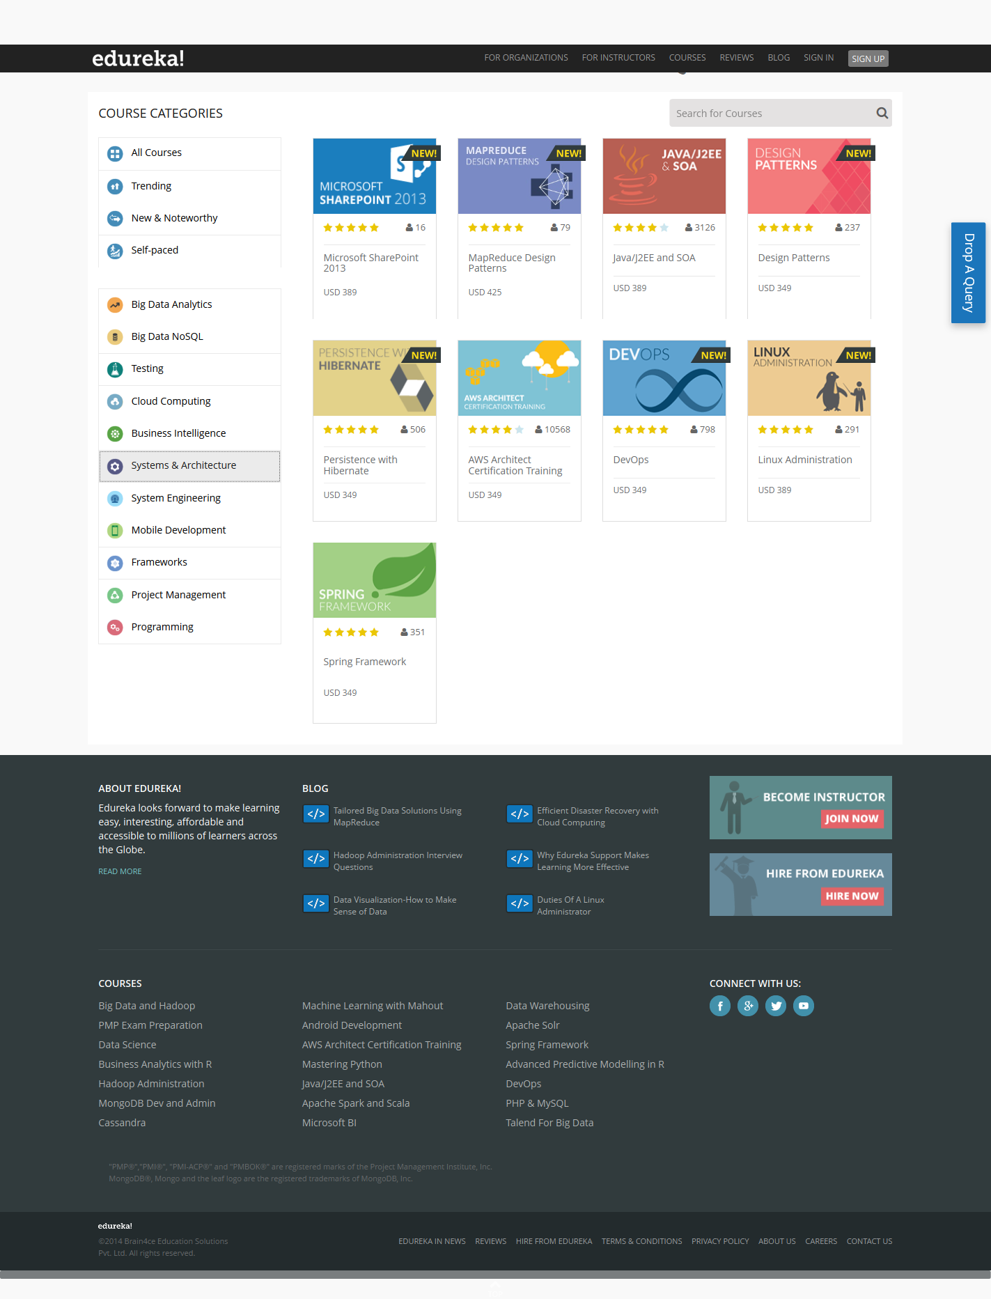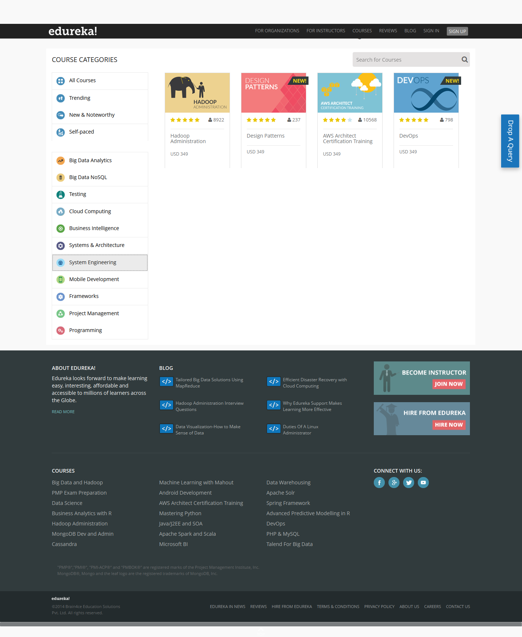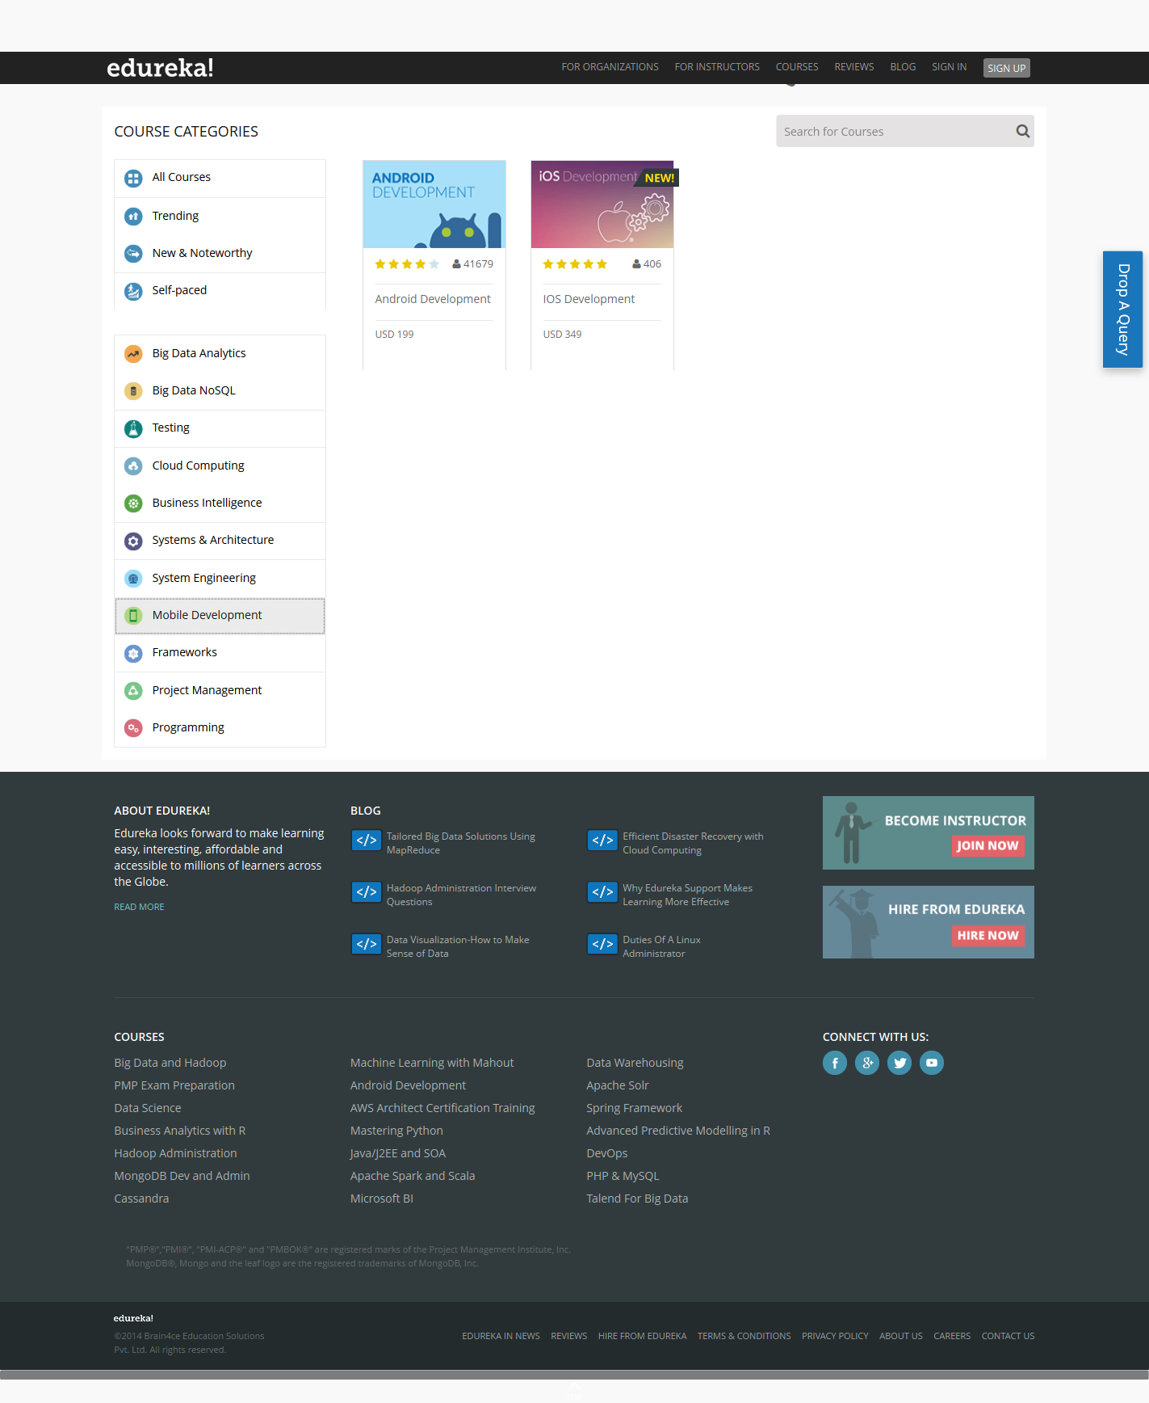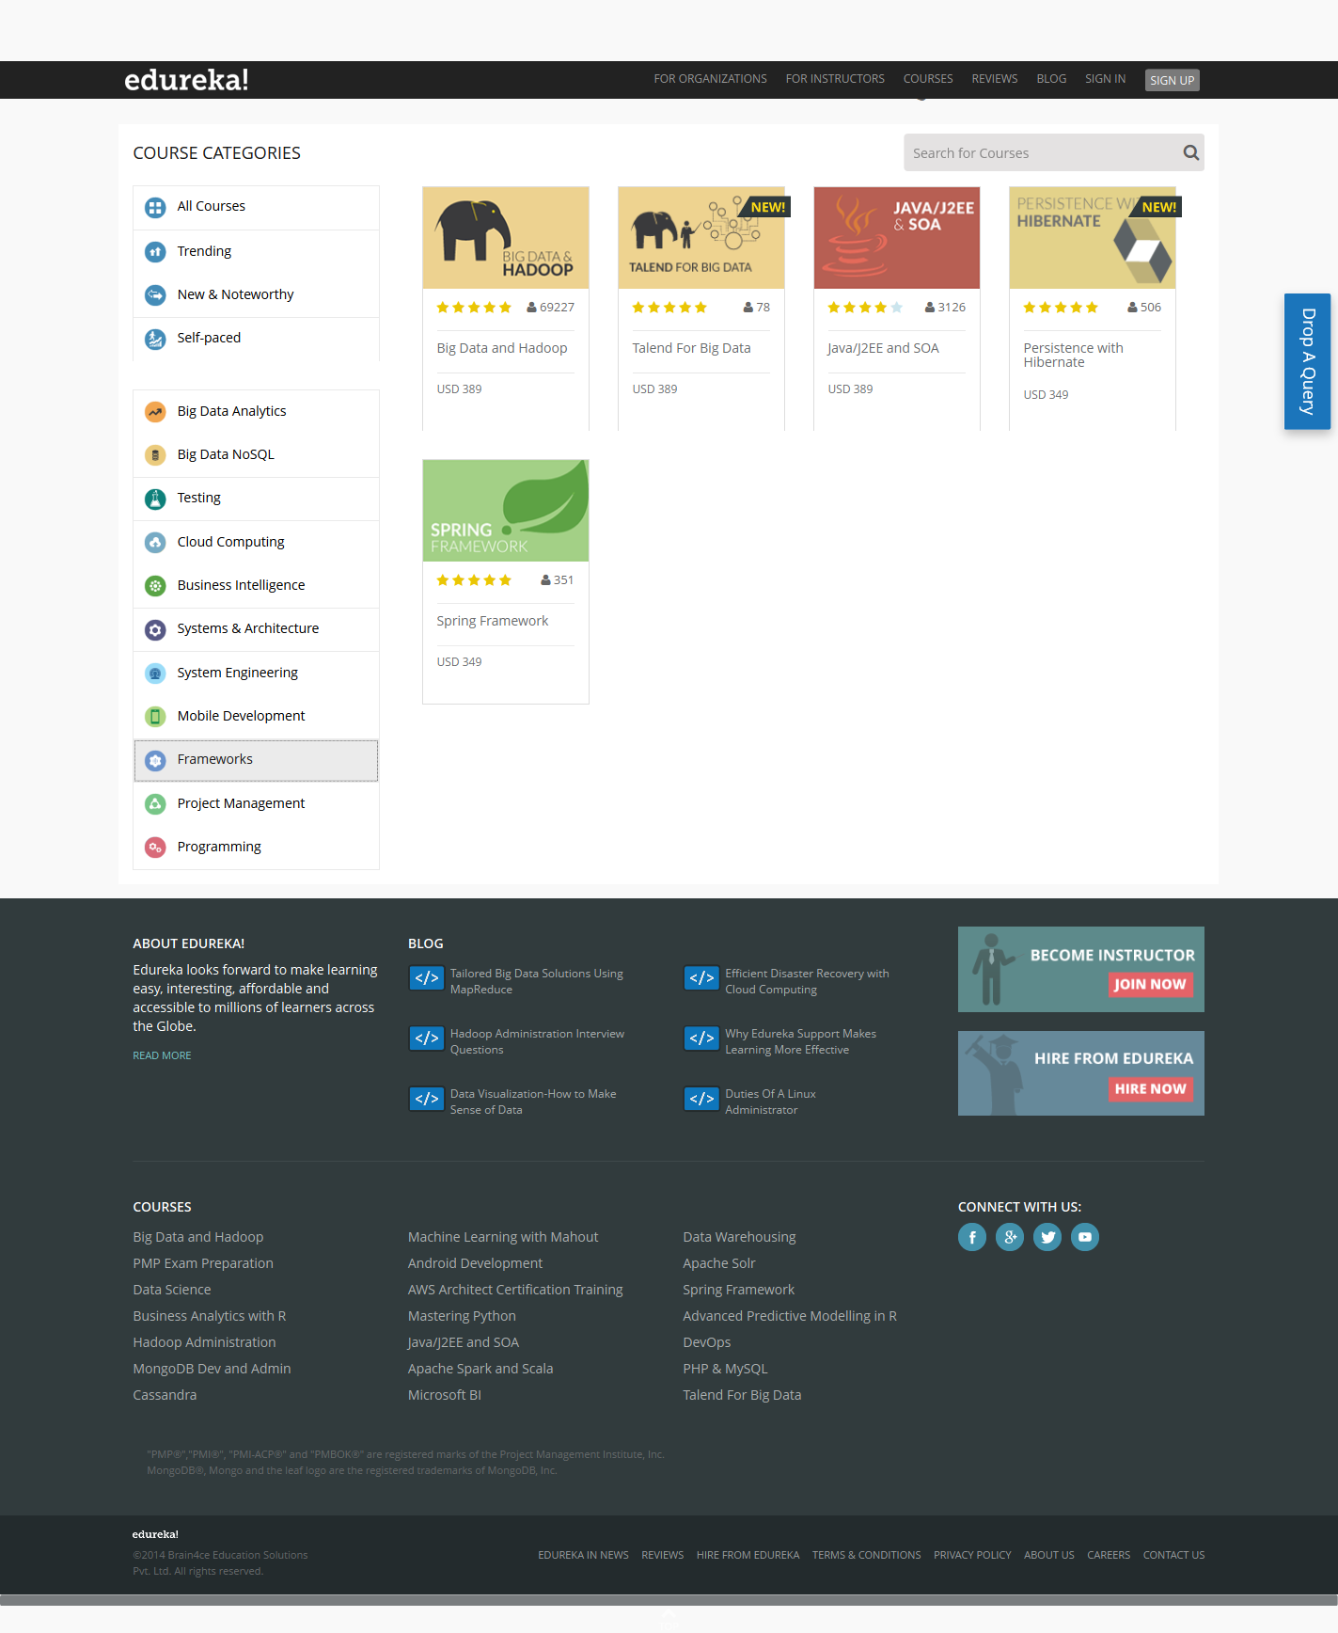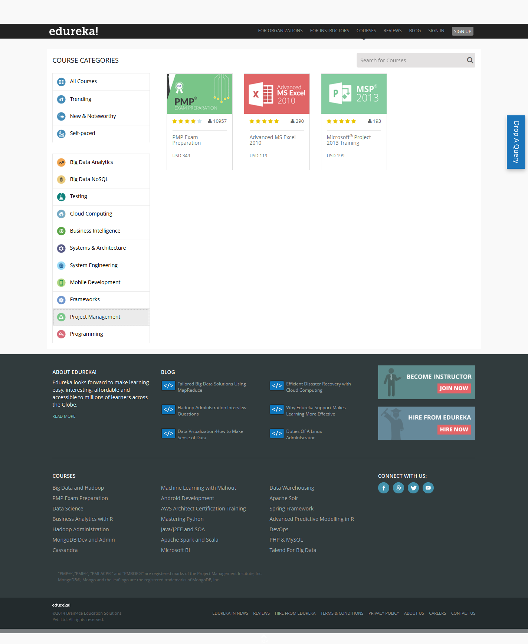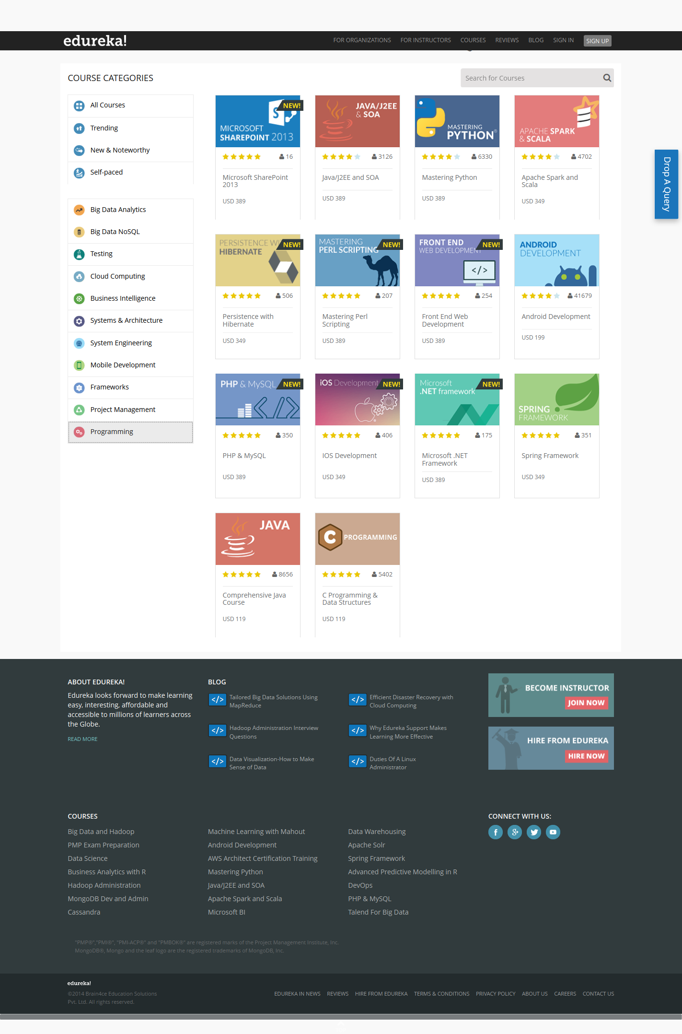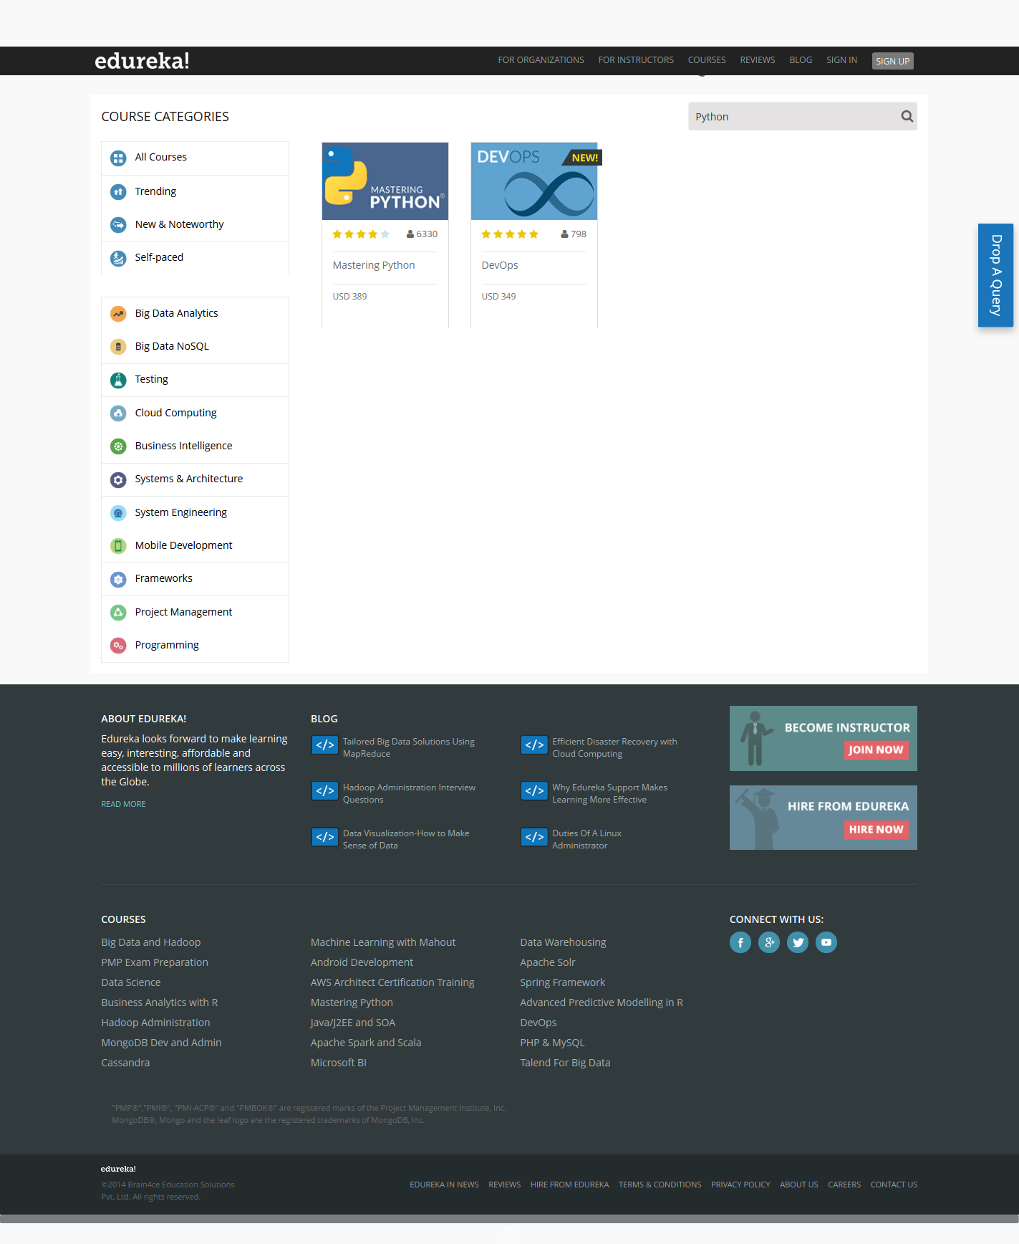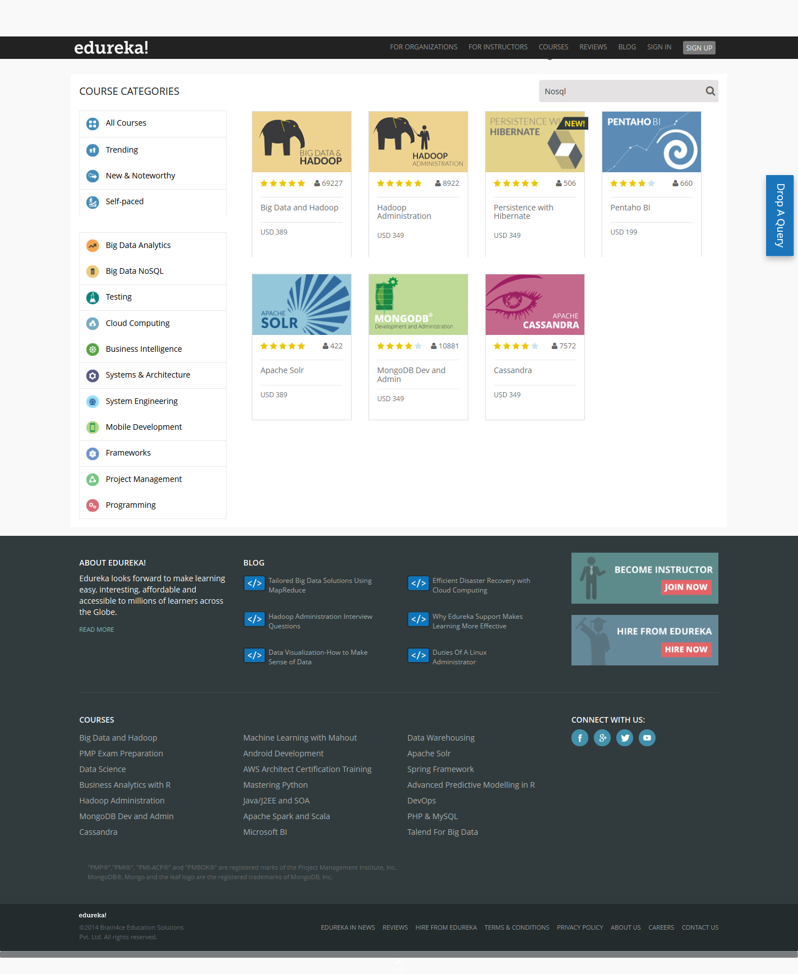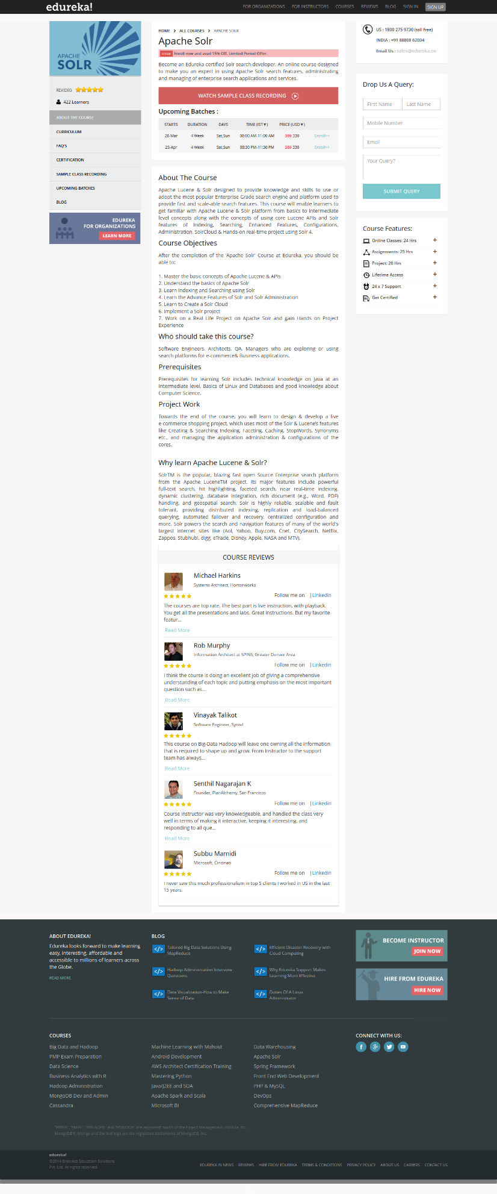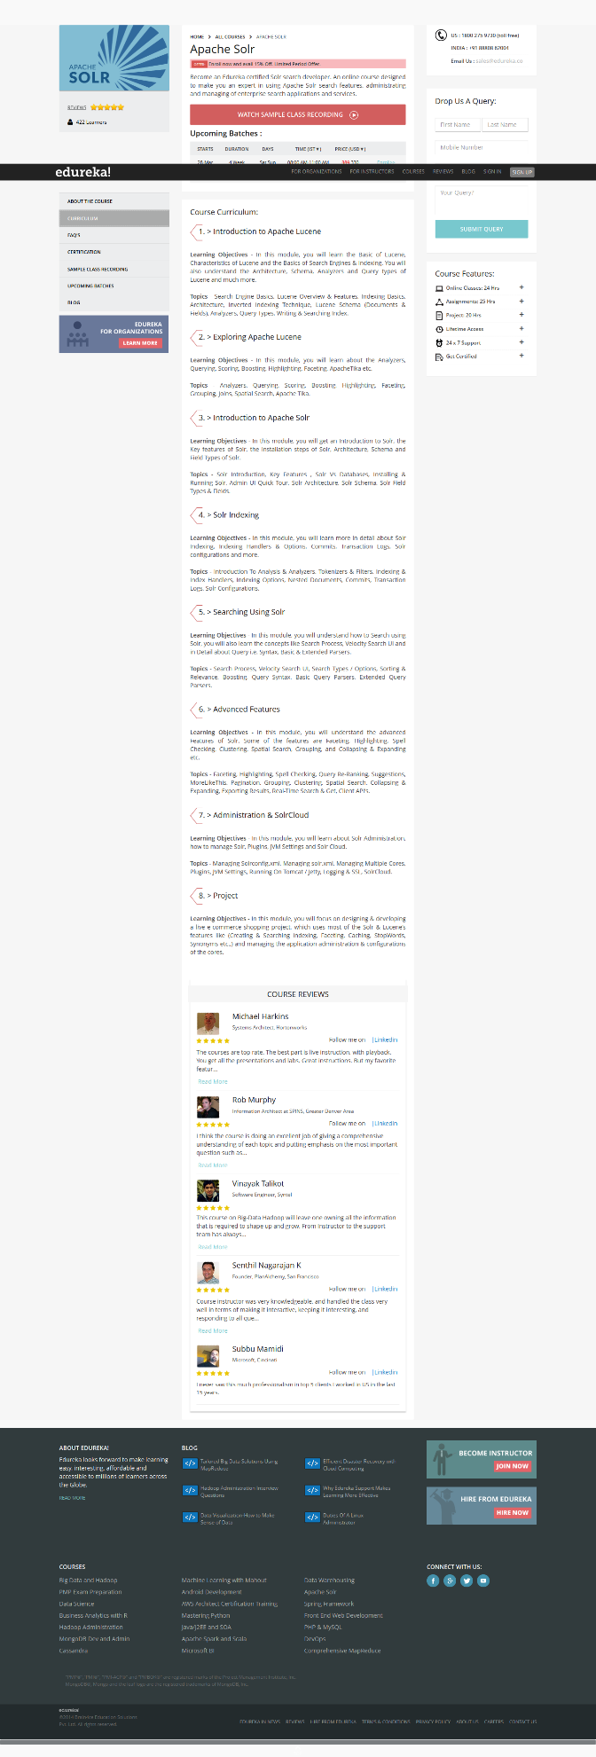

Testing Courses

Cloud Computing Courses

BI Courses

Systems & Architecture

Systems Engineering

Mobile Development

Frameworks

Project Management

Programming

Search for Python in search box

Search for Nosql in textbox

View Apache Solr course

View Curriculum

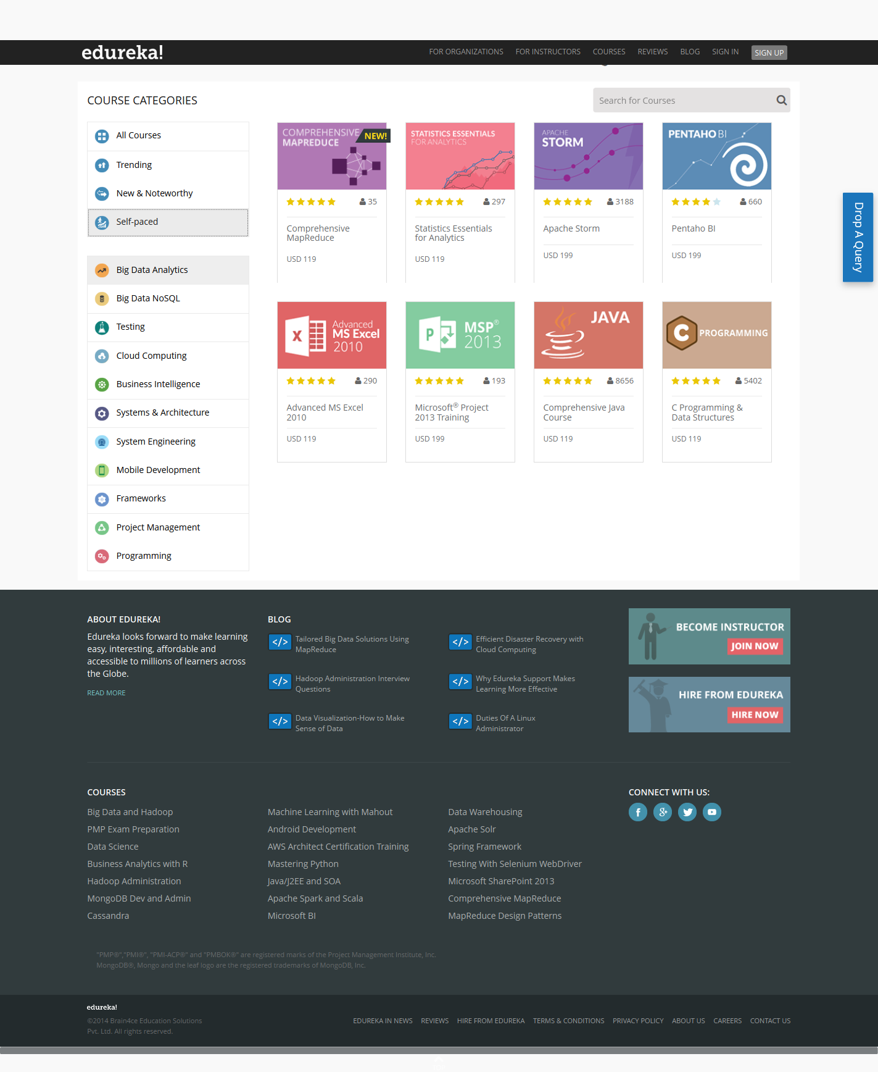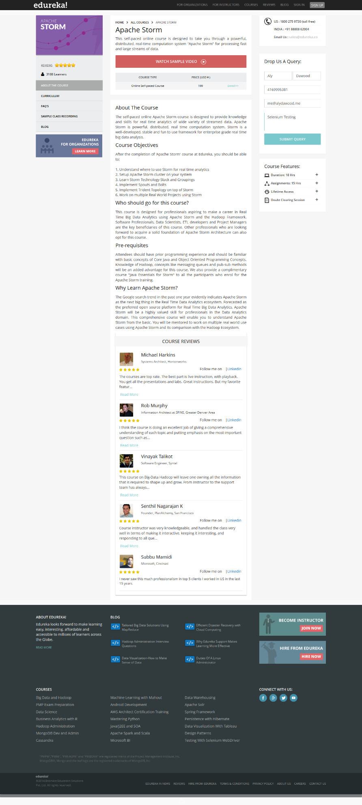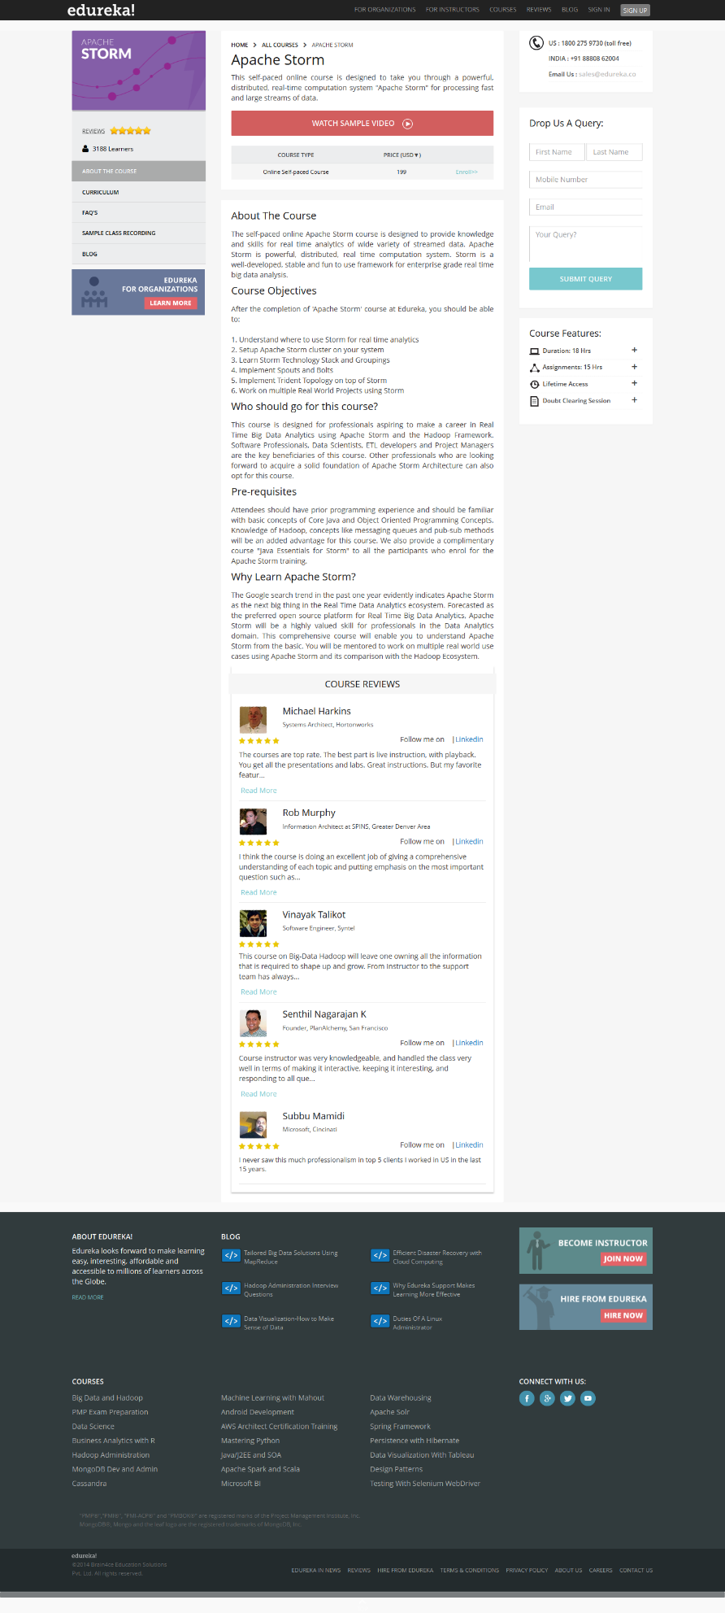

View Self-paced courses

View Apache Strom Course and **fill out query**

Clear out query field

All Test Cases Passed

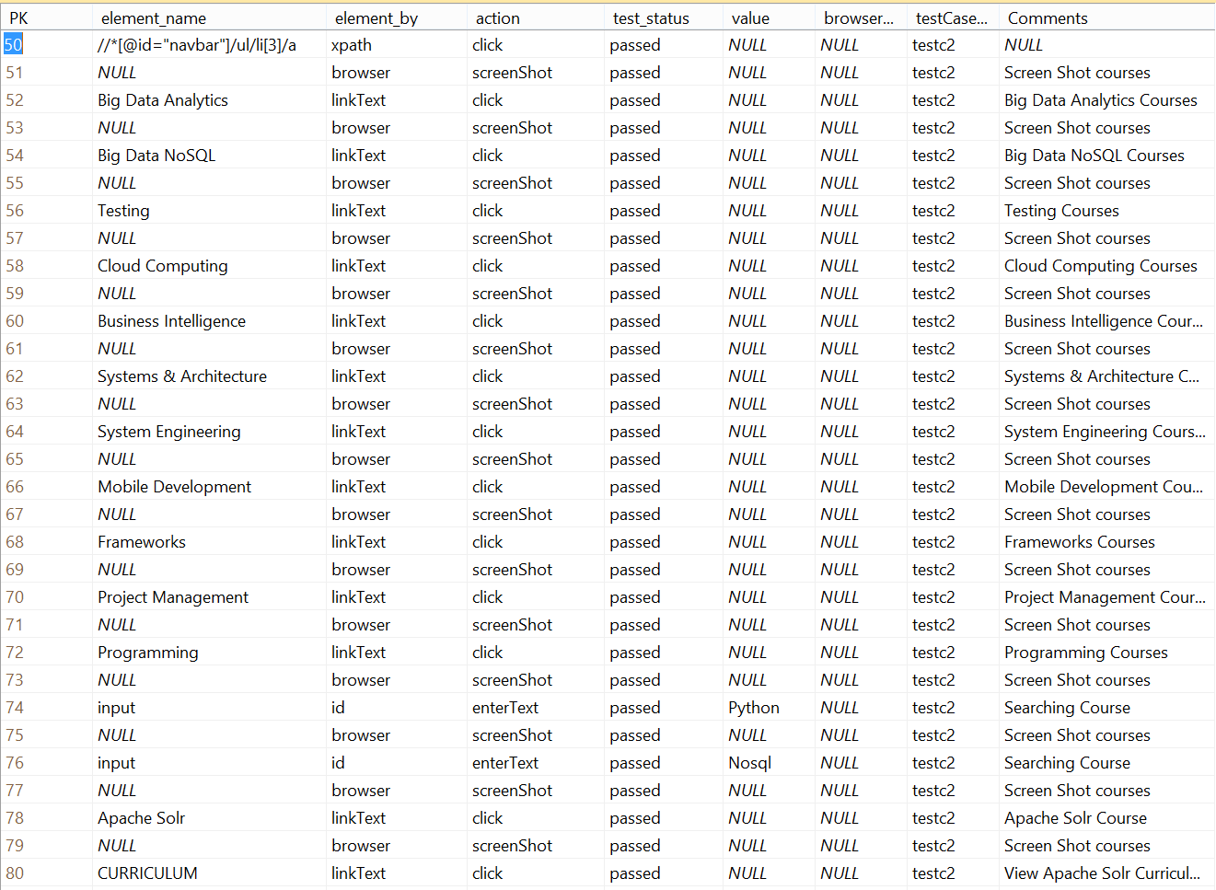

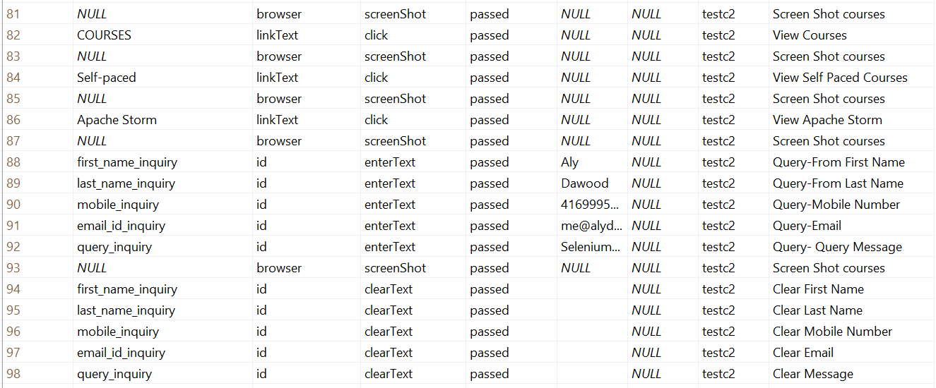

2.0 **Hyundai Motors Canada**

In this test case. Selenium will load Hyundai Canada Motors page and do the following:

* Load web page
* Choice option to Build and price a car
* Select Car **Veloster Turbo**
* Change color to **Vitamin C**
* Change color to **Red**
* Select **Accessories**
* Select **External** **Accessories**
* Select **Hood Protector**

**Hyundai testing *configuration table*.**

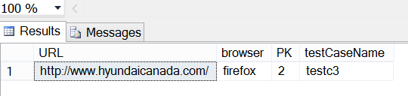

**Hyundai test cases *table*.**

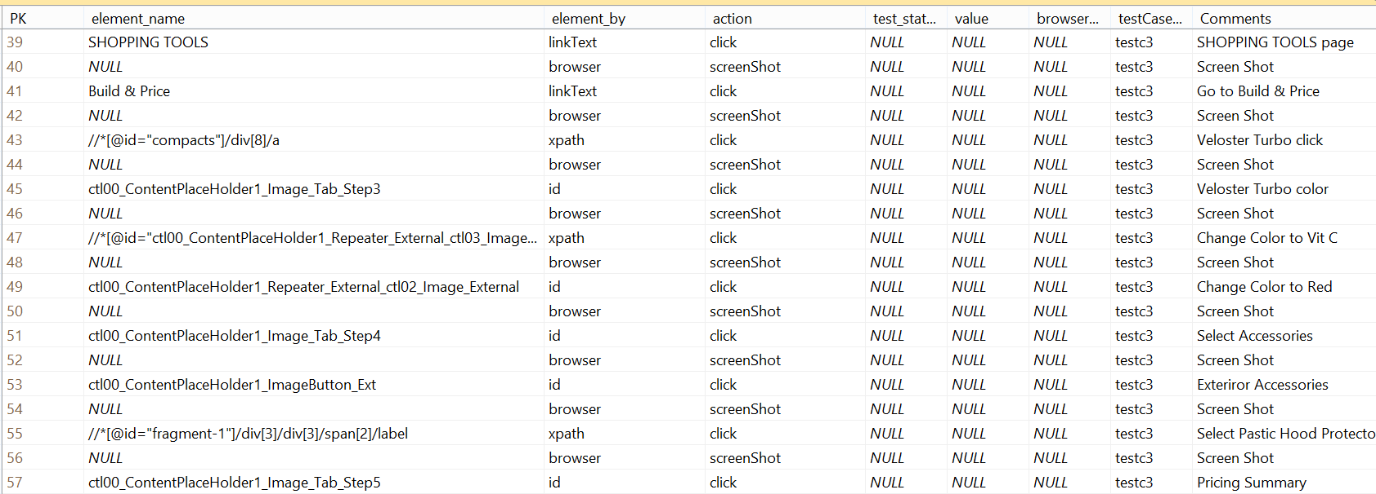

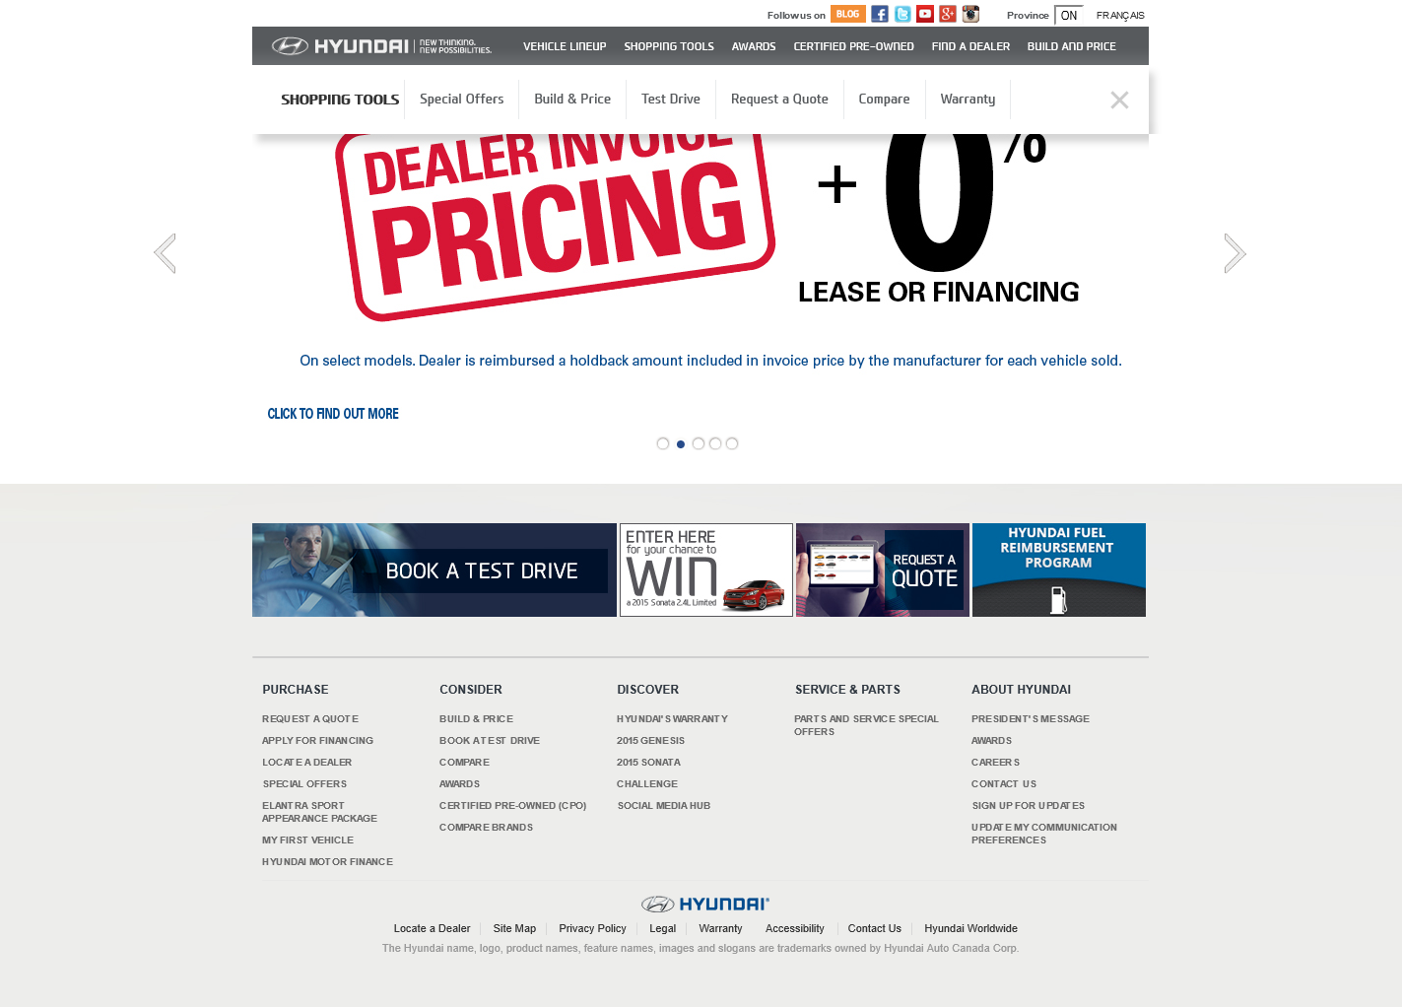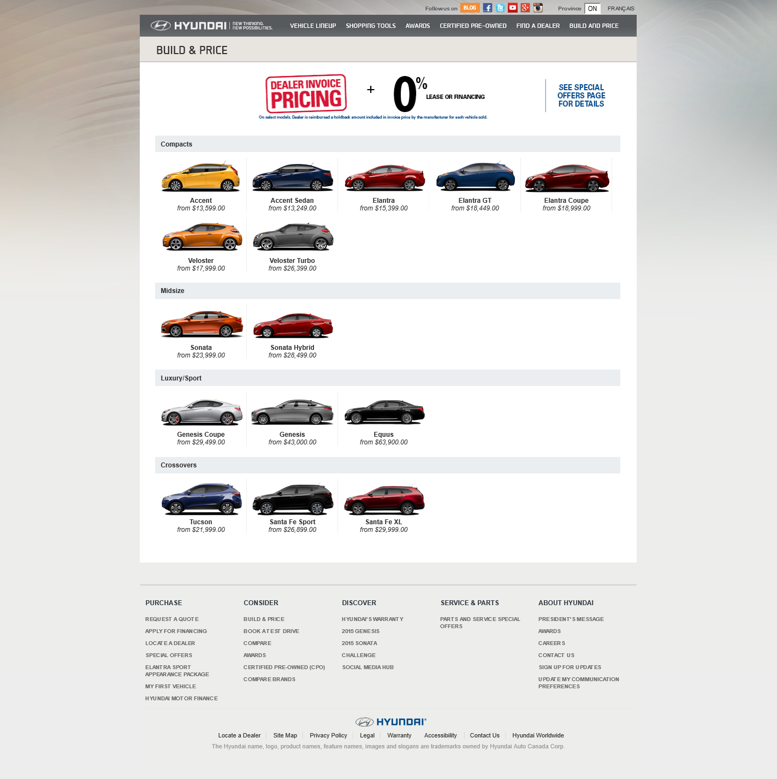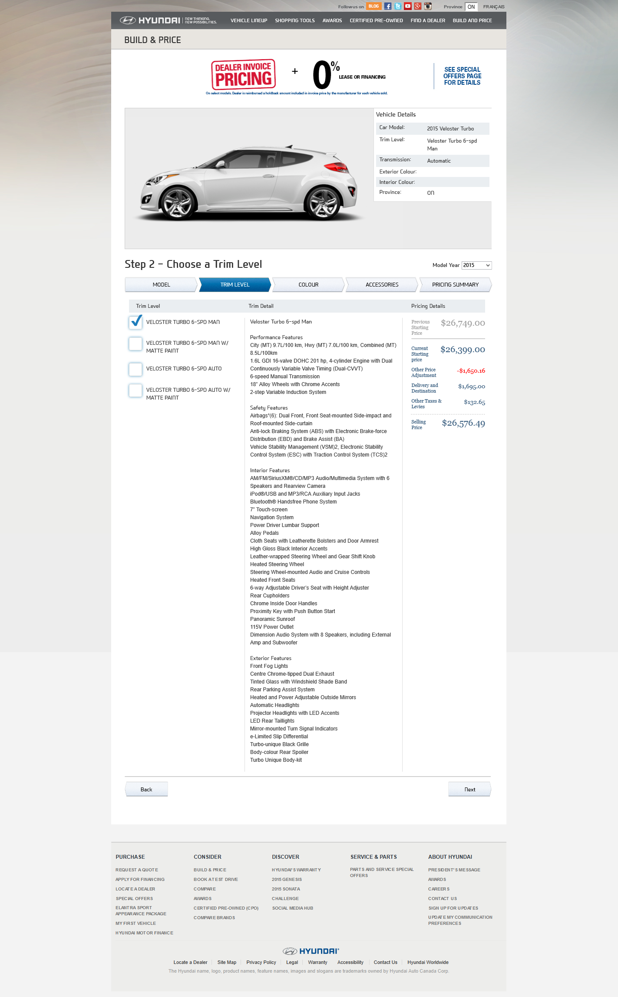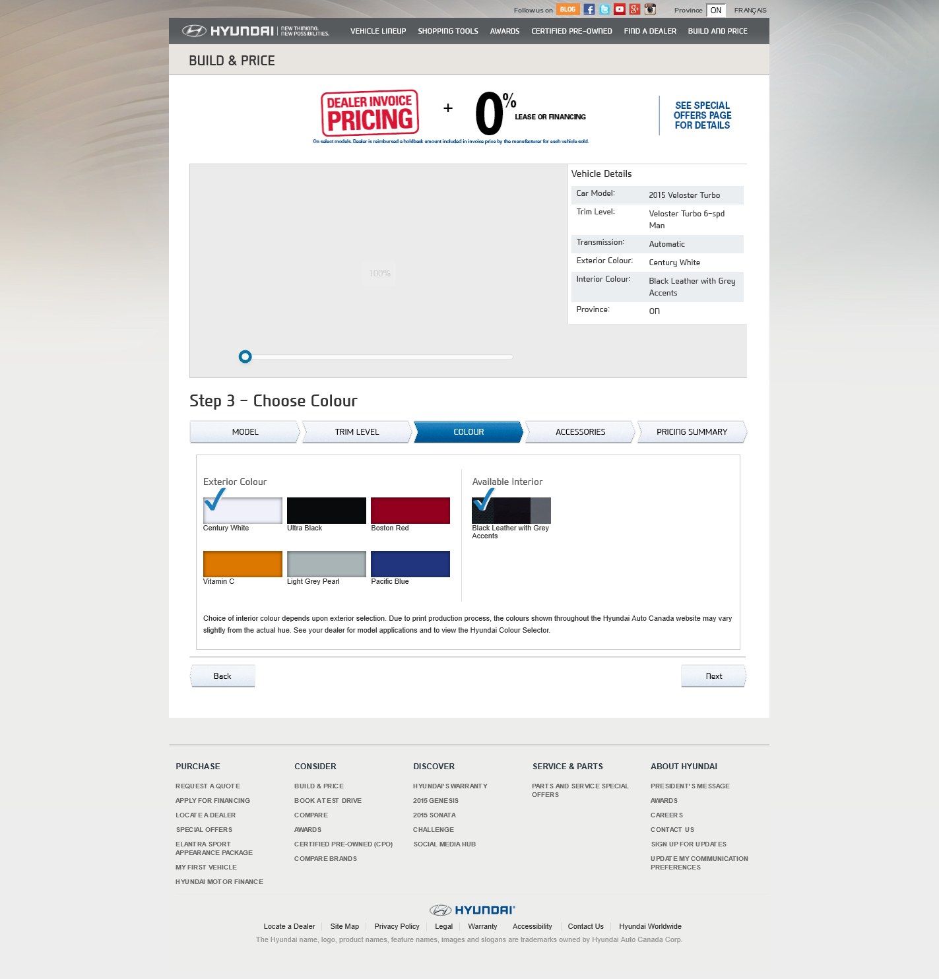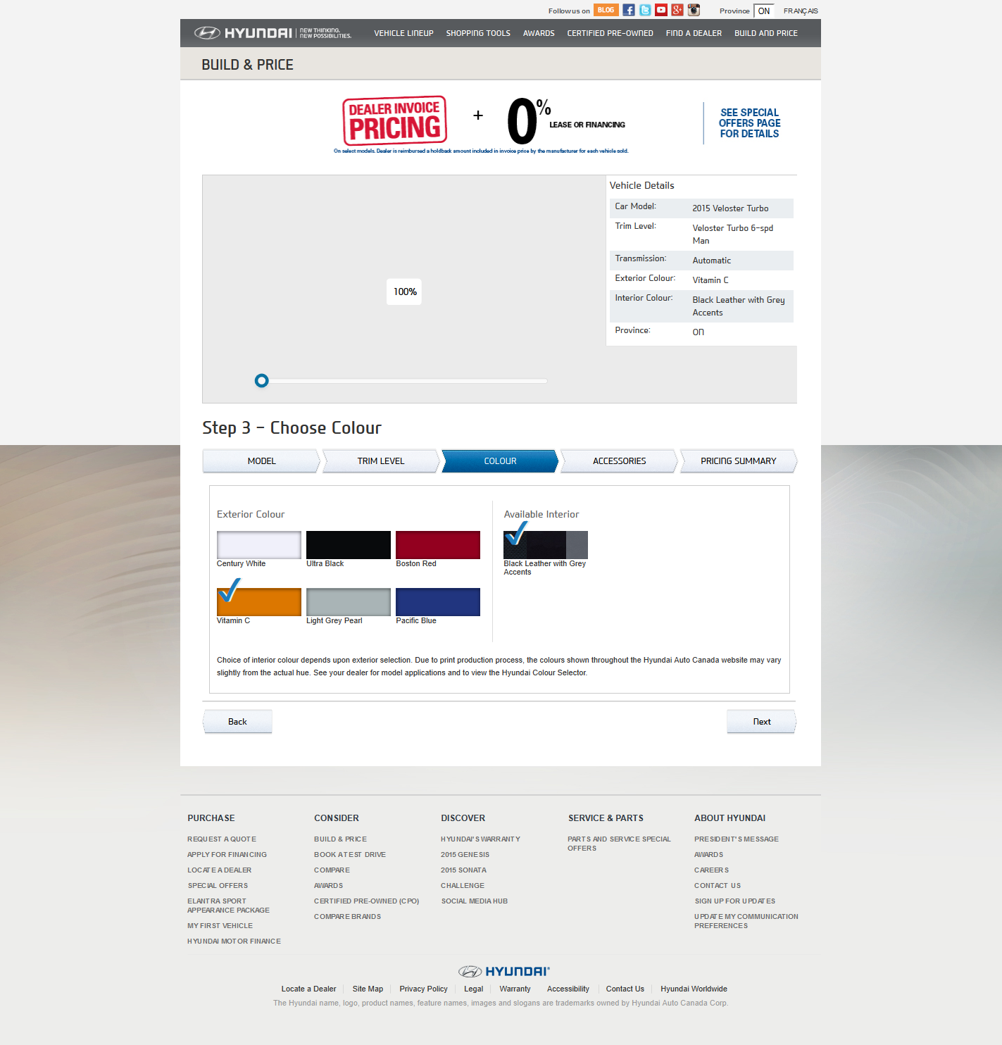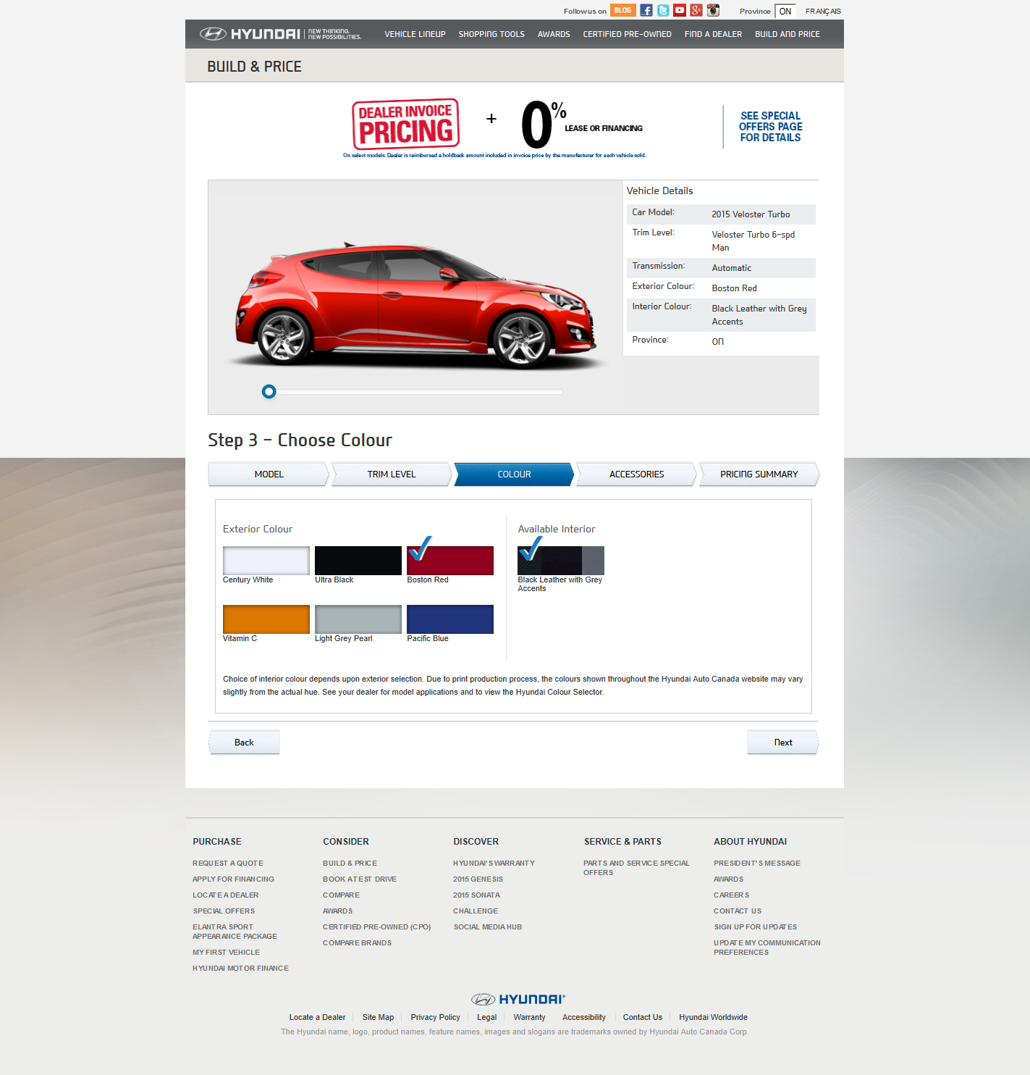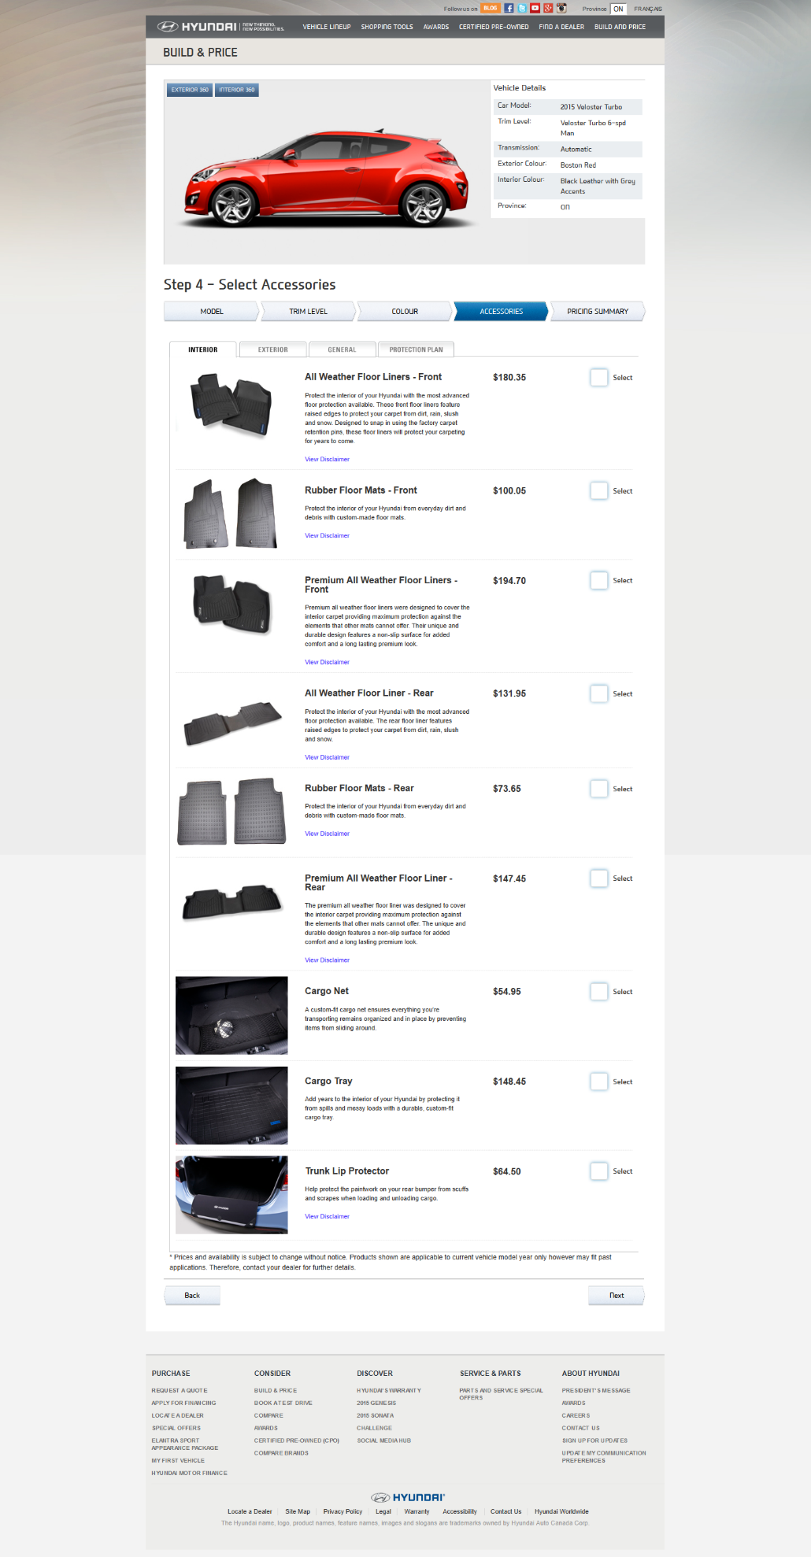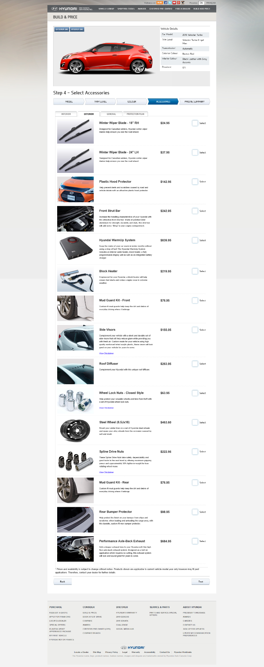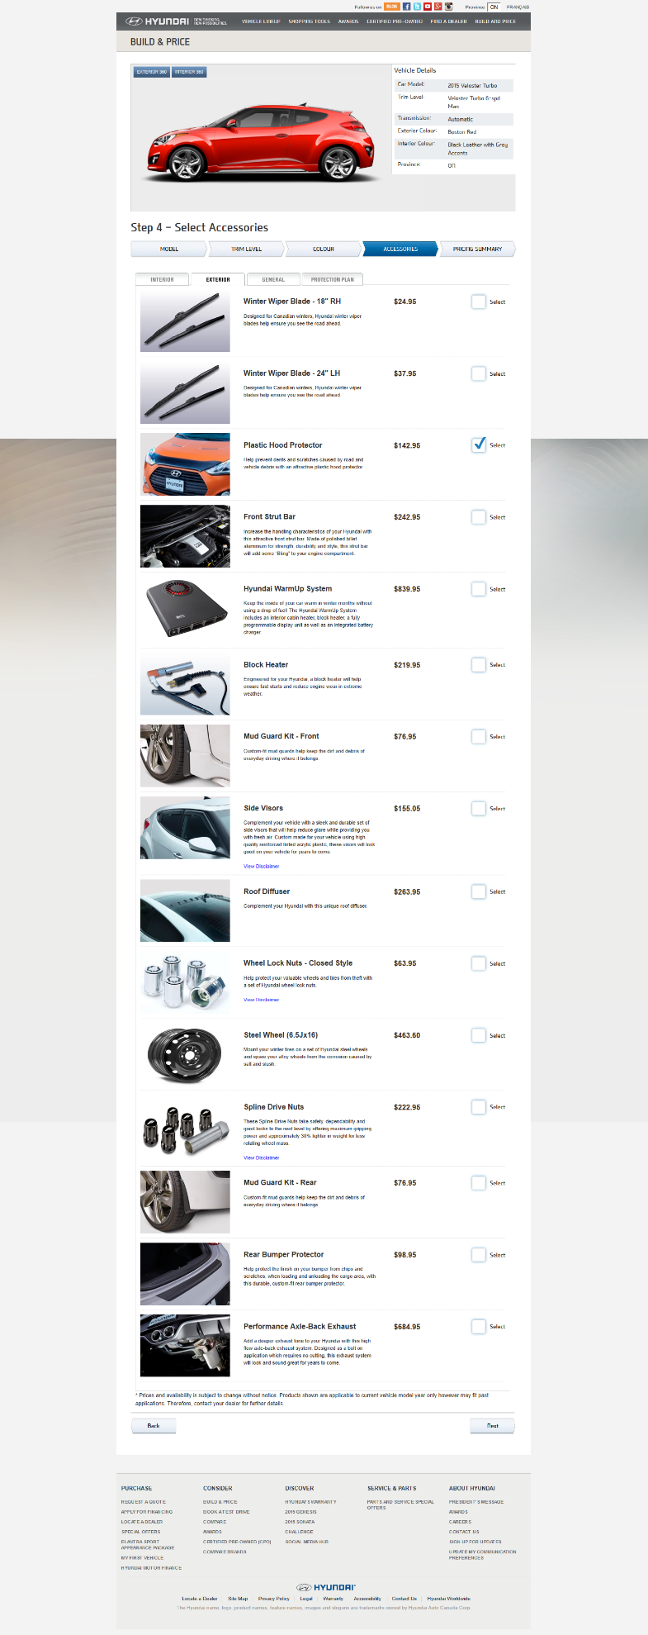

Hyundai website

Selected **Build and Price**

Selected **Veloster Turbo**

Select Color Tab

Select **Vitamin C**

Select Red

Select Accessories

Select External Accessories

Select Hood Protector